Customer Personality Analysis

Introduction
The Customer Personality Analysis dataset contains customer demographic information, income details, purchasing behavior, and marketing campaign responses. The dataset helps businesses understand customer preferences, spending habits, and campaign effectiveness. It consists of customer attributes such as age, education, marital status, income, product purchases, and campaign acceptance history.

Objective
The objective of this task is to clean and preprocess the Customer Personality Analysis dataset by identifying and handling missing values, removing duplicate records, standardizing data formats, and preparing the dataset for further analysis.

Dataset Information

Dataset Name: Customer Personality Analysis

The dataset contains customer demographic information, income details, purchasing behavior, and marketing campaign responses. The dataset is used to understand customer characteristics and improve marketing strategies.
Tools Used
- Python
- Pandas
- NumPy
- Jupyter Notebook / VS Code
- Google colab
Data Cleaning Process
- Loading the Dataset
The dataset was imported into Python using the Pandas library.
- Checking Dataset Structure
- Examined the number of rows and columns.
- Reviewed column names and data types.
- Handling Missing Values
- Checked for null values using isnull().
- Missing values in the Income column were handled using median imputation.
- Removing Duplicate Records
- Duplicate rows were identified and removed using drop_duplicates().
- Standardizing Column Names
- Converted all column names to lowercase.
- Replaced spaces with underscores for consistency.
- Converting Date Format
- Converted the Dt_Customer column into datetime format.
- Data Type Verification
- Verified that numerical and date columns were assigned appropriate data types.

Data Quality Checks
The following checks were performed:
- Missing Value Analysis
- Duplicate Record Analysis
- Data Type Verification
- Column Name Standardization
- Date Format Validation

Summary of Changes
Cleaning Activity | Action Taken
Missing Values | Checked and handled appropriately
Duplicate Records | Removed duplicate rows
Column Names | Standardized to lowercase format
Date Format | Converted to datetime format
Data Types | Verified and corrected where necessary

Exploratory Data Analysis (EDA)
Exploratory Data Analysis was conducted to understand patterns and trends within the dataset.

Analysis Performed:
- Income distribution analysis.
- Age distribution analysis.
- Marital status distribution.
- Product spending analysis.
- Customer Behaviour correlation Heat Map.
- Campaign Acceptance
EDA helped identify customer demographics and purchasing patterns.
Visualizations

1.Income Distribution Analysis
Income Distribution Analysis was performed to understand the financial background of customers. This analysis helps identify the range of customer incomes and determine whether the majority of customers belong to low, middle, or high-income groups. Understanding income distribution is important because customer purchasing power often influences spending behavior and marketing effectiveness.
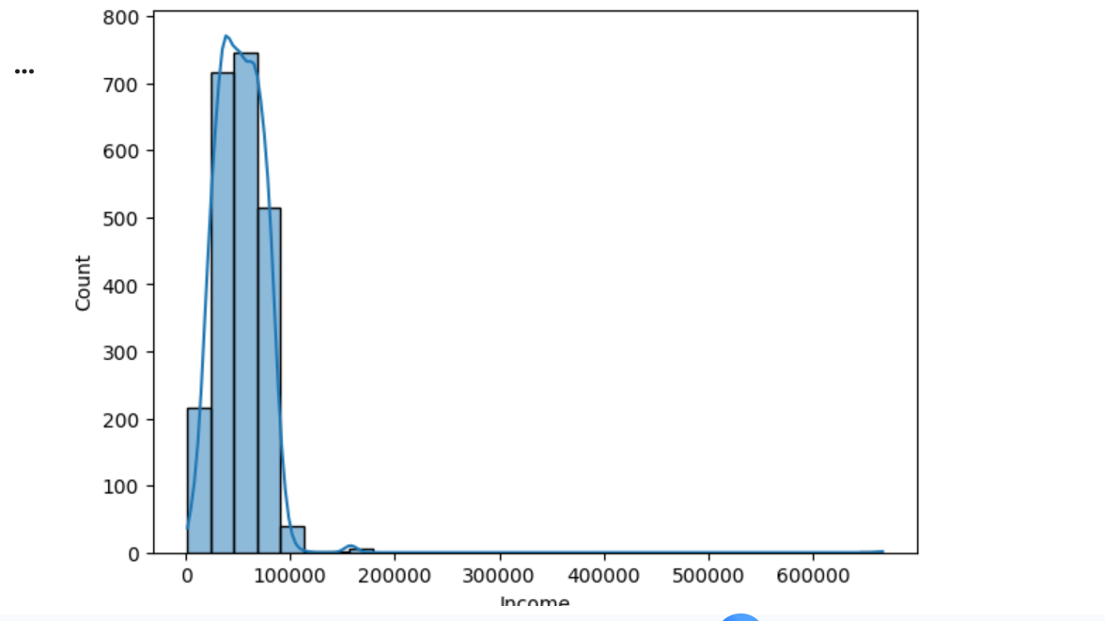

2.Age Distribution Analysis
Age Distribution Analysis was conducted to examine the age groups of customers within the dataset. This analysis helps identify the dominant age segments and understand how customer age may influence purchasing decisions. The results can support age-based customer segmentation and targeted marketing strategies.

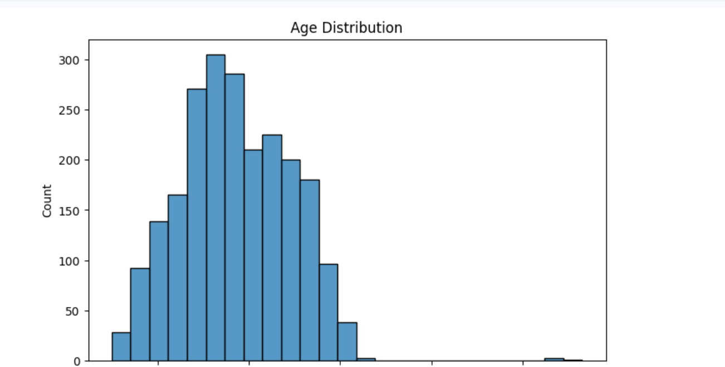
3.Marital Status Distribution
Marital Status Distribution Analysis was used to understand the composition of customers based on their relationship status, such as Single, Married, Together, Divorced, or Widowed. This analysis provides insights into customer demographics and helps businesses design personalized marketing campaigns for different customer groups.
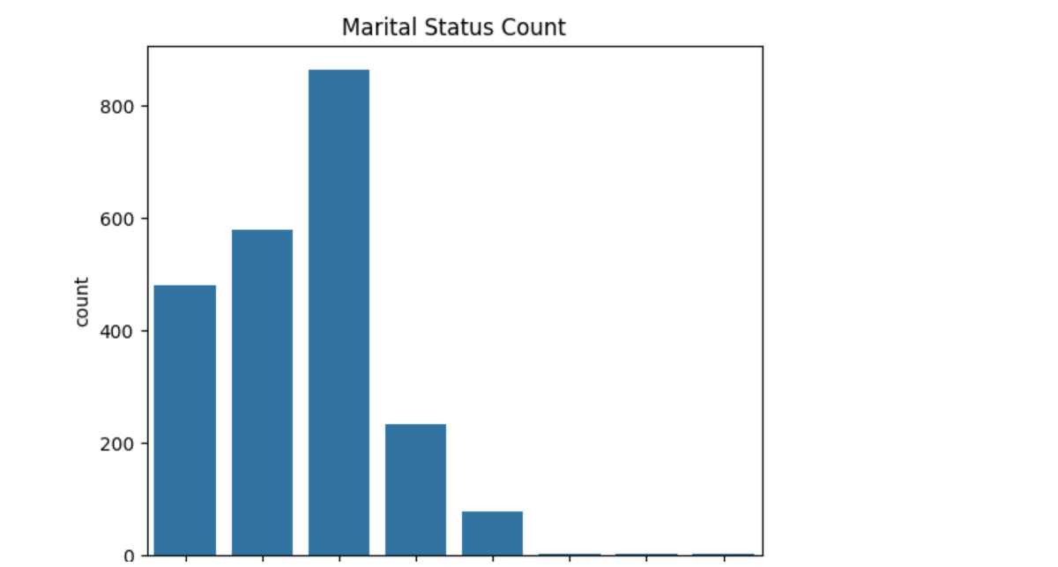

4.Product Spending Analysis
Product Spending Analysis was performed to evaluate customer expenditure across different product categories, including wines, fruits, meat products, fish products, sweet products, and gold products. This analysis helps identify the most popular product categories and understand customer purchasing preferences, enabling businesses to optimize product offerings and promotional strategies.
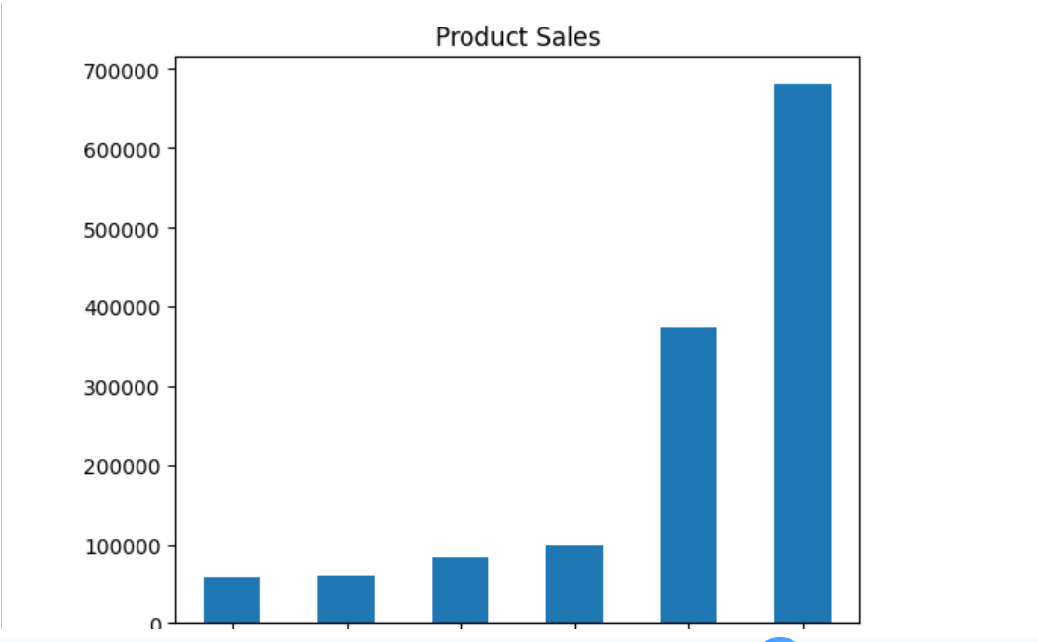

5. Customer Behavior Correlation Heat Map
The Customer Behavior Correlation Heat Map was created to visualize relationships between various customer attributes and purchasing behaviors. Correlation values indicate the strength and direction of relationships between variables such as income, spending, purchases, and campaign responses. This analysis helps identify key factors that influence customer behavior and supports data-driven decision-making.

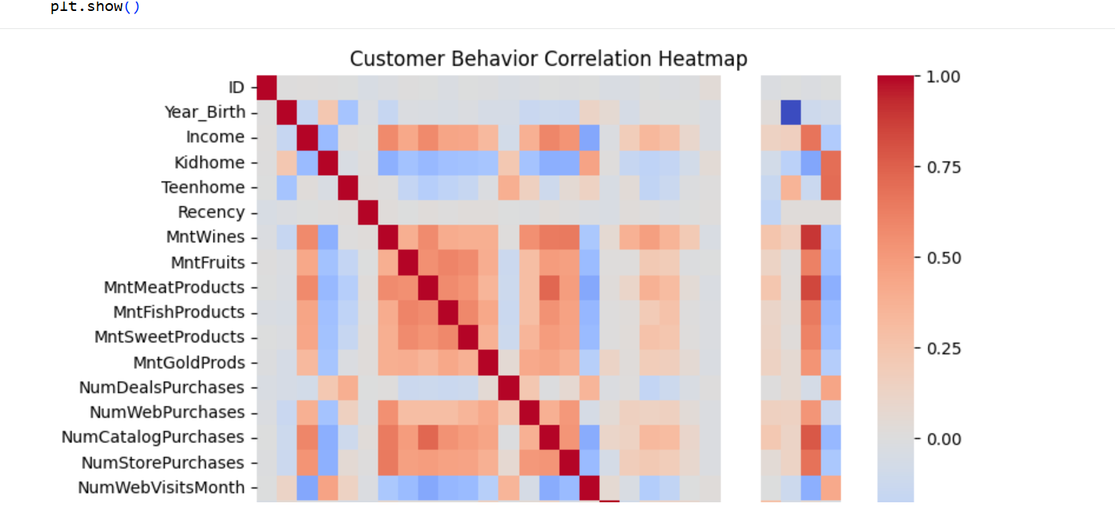

6. Campaign Acceptance Analysis
Campaign Acceptance Analysis was conducted to evaluate customer responses to previous marketing campaigns. The analysis examines the acceptance rates of different campaigns and identifies which campaigns were most successful. These insights help businesses understand customer engagement levels and improve the effectiveness of future marketing efforts.
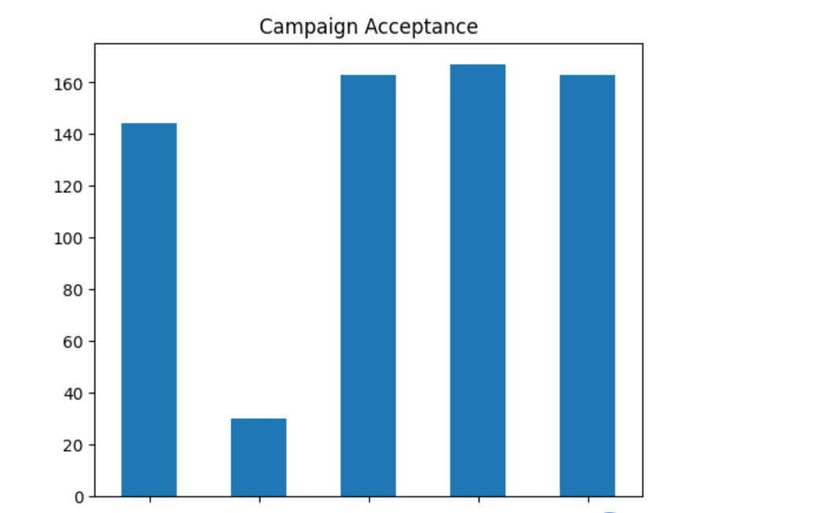

Key Learnings
- Learned how to identify missing values in real-world datasets.
- Understood the importance of removing duplicate records.
- Gained experience in standardizing and formatting data.
- Improved skills in using Pandas for data preprocessing.
- Prepared a clean dataset suitable for analysis and visualization.

Business Insights
Based on the analysis, the following business insights were identified:
- High-income customers contribute significantly to total revenue.
- Wine and meat products are the most popular categories.
- Customers with fewer dependents tend to spend more.
- Previous campaign responders are valuable targets for future campaigns.
- Digital marketing strategies can focus on customers with high web purchasing activity.
- Customer segmentation can improve campaign performance and marketing efficiency.
Conclusion
The Customer Personality Analysis dataset was successfully cleaned and preprocessed. Missing values, duplicate records, inconsistent formats, and data type issues were addressed. The final cleaned dataset is structured, reliable, and ready for further exploratory data analysis and business insights generation.

